Color Pallet:
Primary Colors
- 🔵 Primary Blue: #168af7 (Buttons, Active States, Highlights)
- 🟢 Success Green: #10b981 (Paid Status, Success Messages)
- 🔴 Danger Red: #c02828 (Unpaid Status, Delete Actions, Errors)
Backgrounds & Gradients
- 🟡 Gold (Gradient End): #b99700 (Bottom-right of page background)
- ⚪ Light Grey (Gradient Start): #eeeeee (Top-left of page background)
- 🌫️ Glass White: rgba(255, 255, 255, 0.65) (Card Backgrounds)

Landing Page
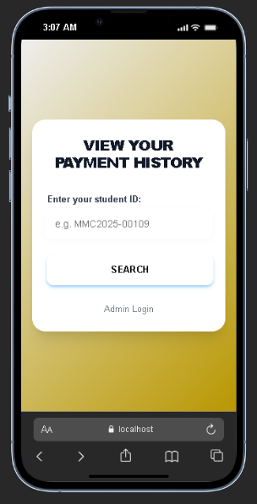

Student Fines View
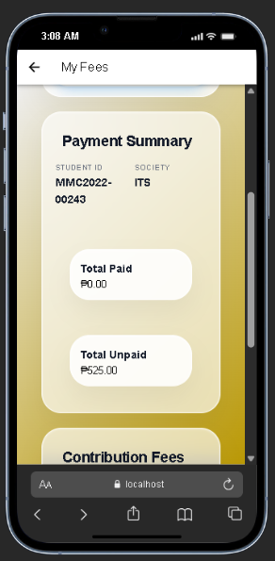

Login Page
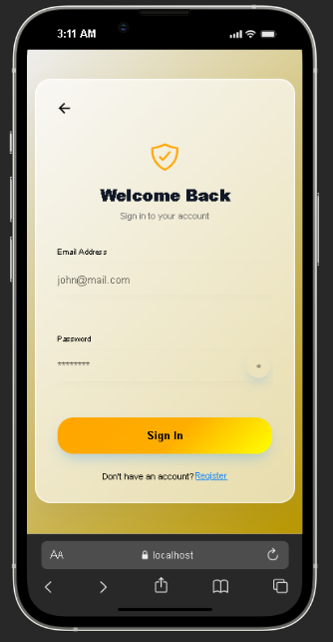

Sign Up Page
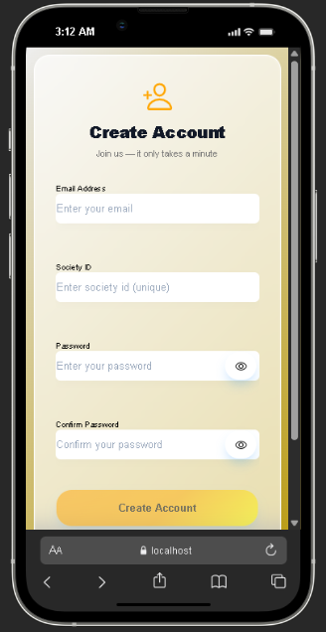

Admin Dashboard
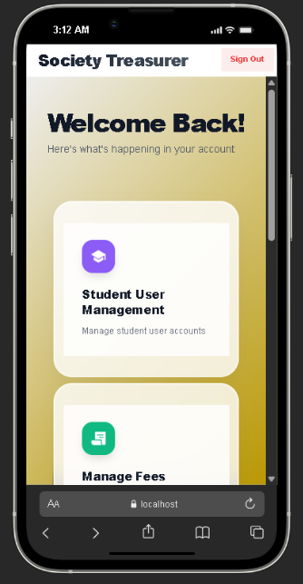

Student User Management
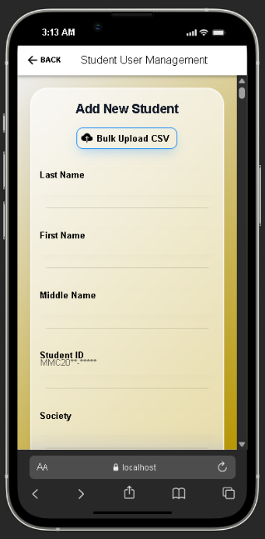

Manage Fees
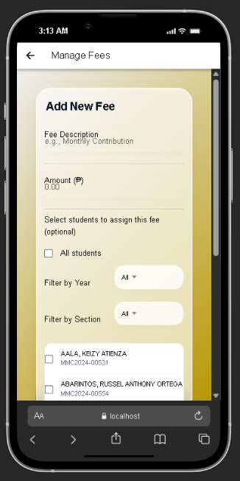

Track Payments
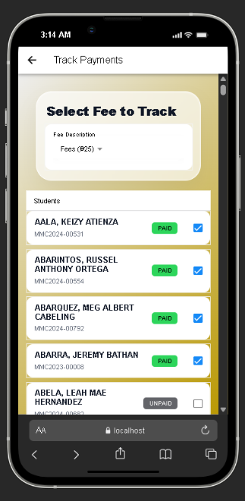

Outstanding Balance Report
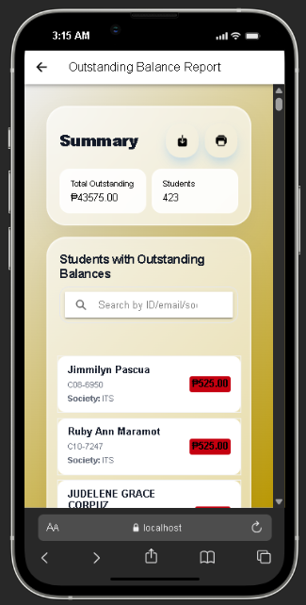

Homeroom Treasurer Management
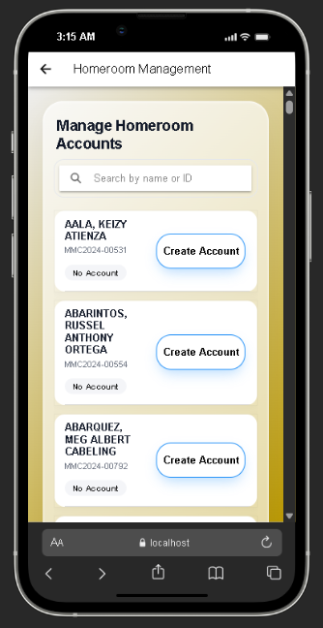

Homeroom Treasurer Dashboard
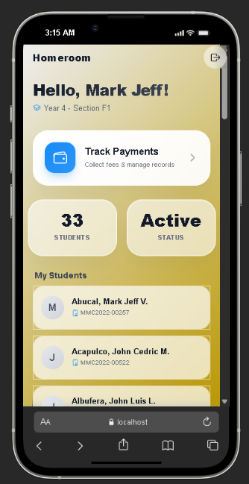

1. Users Collection (users)
Stores the profiles for all authenticated users (Admins, Homeroom Treasurers, and Students).
Field | Type | Description
uid | String | (PK) The Firebase Auth User ID.
email | String | User's email address.
role | String | 'admin', 'student', or 'homeroom'.
societyId | String | Links the user to a specific Society/Organization (Admin's UID).
studentId | String | (Student/Homeroom only) The school ID (e.g., MMC2025-xxxxx).
yearLevelId | String | (Student/Homeroom only) Year level (e.g., "4").
sectionId | String | (Student/Homeroom only) Section (e.g., "A").
firstName | String | First name.
lastName | String | Last name.
createdAt | String | ISO 8601 Timestamp.
createdBy | String | UID of the Admin who created this account.

2. Fees Collection (/fees)
Stores the contribution fees created by Admins.
Field | Type | Description
id | String | (PK) Auto-generated Document ID.
description | String | Name of the fee (e.g., "Christmas Party Fee").
amount | Number | The cost of the fee (e.g., 150.00).
societyId | String | The ID of the society this fee belongs to.
createdBy | String | UID of the Admin who created the fee.
targetYearLevel | String | (Optional) If set, applies only to this Year Level.
targetSection | String | (Optional) If set, applies only to this Section.
createdAt | String | ISO 8601 Timestamp.

3. Payments Collection (/payments)
Stores the transaction records linking a Student to a Fee.
Field | Type | Description
id | String | (PK) Auto-generated Document ID.
studentId | String | The Student ID (e.g., MMC2025-xxxxx) of the payer.
feeId | String | The ID of the Fee being paid.
status | String | 'paid', 'unpaid', or 'pending' (Waiting for remit).
societyId | String | The society this payment belongs to.
paidAt | String | (Optional) Timestamp when status became 'paid'.
paidBy | String | (Optional) UID of the Admin/Homeroom who marked it.
notes | String | (Optional) Remarks or notes.
createdAt | String | ISO 8601 Timestamp.

4. Students Collection (/students)
A public-read collection used for the Landing Page lookup. This allows students to check their fees without logging in. It mirrors the data in users but is optimized for search.
Field | Type | Description
studentId | String | (PK) The Student ID (e.g., MMC2025-xxxxx).
email | String | Student's email.
firstName | String | First name.
lastName | String | Last name.
societyId | String | The society they belong to.
yearLevelId | String | Year level.
sectionId | String | Section.
Relationships
- One-to-Many: An Admin (via societyId) manages many Users and Fees.
- Many-to-Many: Students have many Payments (one per Fee).
- Filtering:
  - Homeroom Treasurers can only see Students and Payments where yearLevelId and sectionId match their own profile.
  - Admins can see all data where societyId matches their own.

